***Lab No-04***

***Name of the lab:******File operation and permission***

***Name:******Shuvo Biswas ID:******IT-16014***

***Objective:***

In this lab ,we can learn about

* + - * + File Operation and File Permission in Linux Operating System.
        + Implementation of File Operation and File Permission and how it works in operating system.

**File operation and permission**

**Question-01: What is File?**

**Answer:** A file is a collection of related information that is recorded on

secondary memory.

**Question-02: What is File Operation and File Permission in Linux Operating System?**

**Answer:**

**File Operation:**

For defining a file properly, we need the operations that can be performed on files. The operating system can provide system calls to create, write, read, reposition, delete, and truncate files. There are six basic file operations within an Operating system. These are:

1. **Creating a file**
2. **Writing a file:**
3. **Reading a file**
4. **Repositioning inside a file**
5. **Deleting a file**
6. **Truncating a file**

**File Permission:**

Every file and directory in Linux system has 3 permissions. They are given below:

1) Read  
2) Write  
3) Execute permission

Read (r): this gives permission to open a file or folder and view its contents.

Write (w): this gives permission to overwrite, append-to or delete a file or folder.

Execute (x): this gives permission to "run" a file.

**Question-03:** **Implementation of File Operation and File Permission.**

**and File Permission in Linux Operating System?**

**Implementation of File Operation**

**Answer:**

To use the Linux terminal we will need to know the basics of managing files and navigating directories. Different file operation is given below:

## 01. ls - The ls command stands for list Files.

The ls command lists the files in a directory. By default, **ls** lists files in the current directory.

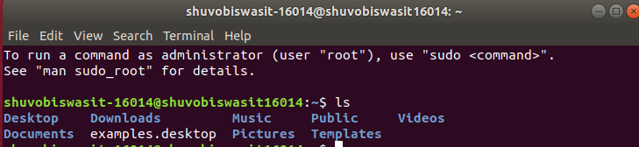

## 02. cd : The cd command stands for Change Directory.

The cd command changes to another directory. For example, cd Desktop will take you to your Desktop directory if you are starting from your home directory.

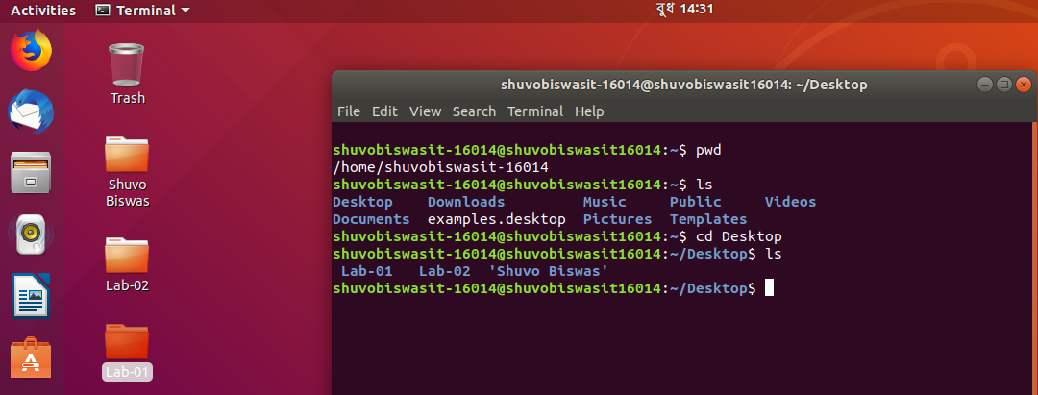

## 03. ls –a: The ls -a command stands for list all files.

List all files including hidden file starting with ‘-‘.

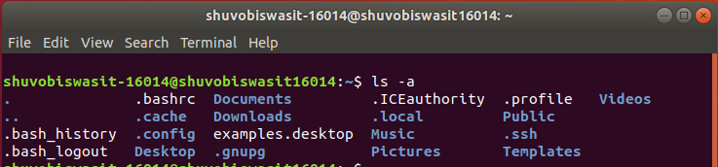

**04. cd .. :** The **cd ..** command stands for change directory to up which is used to move one directories up.

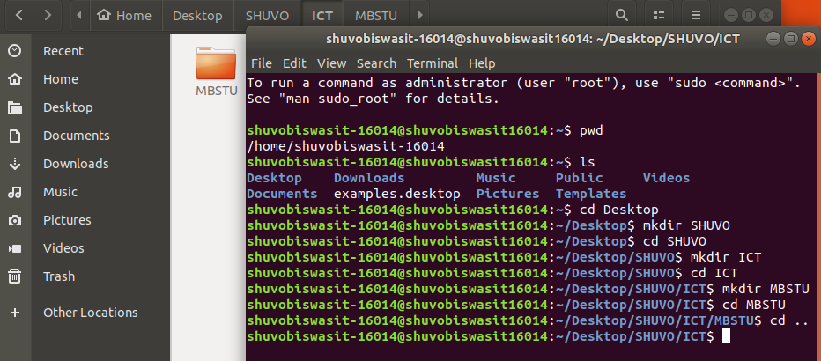

**05. rmdir:** The **rmdir** command stands for remove directory which is used to remove a directory from the desktop.

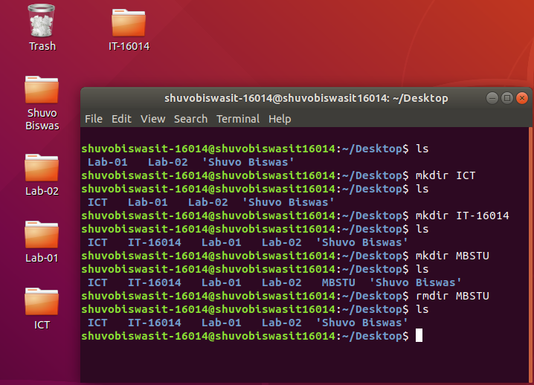

**06. mkdir:** The **mkdir** command stands for make directory which command used to create new directories in a file system.

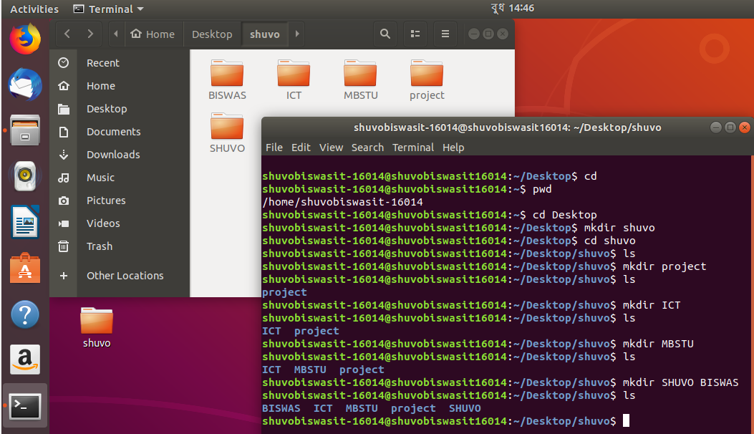

**07. ls –R :** The **ls –R** command stands for list files recursively which used to list all files in directories inside the current directory with recursively .

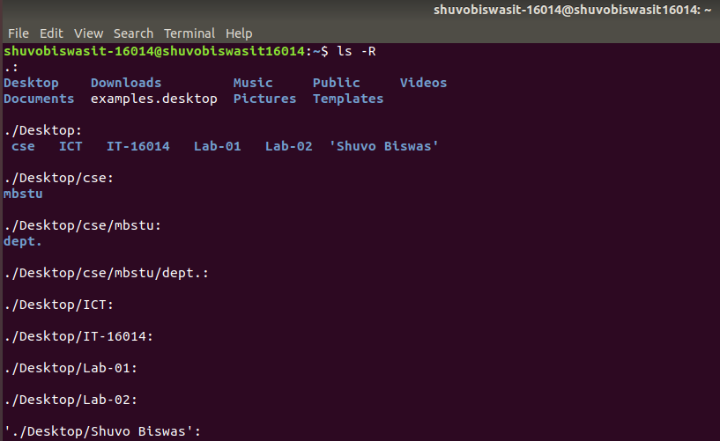

**Implementation of File Permission**

**Answer**

1. ls -l :The **ls –l** command used to show all context in a list. Example: In the below terminal ,the file content total 44 context.

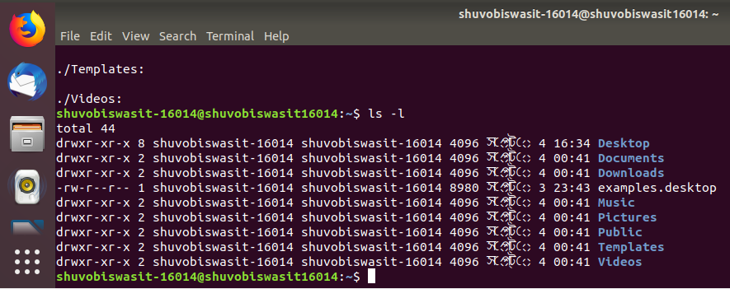

1. **ls –al :** The **ls –al** command used to view all files in a list. Example: here we show that the below terminal a file contains total 92 text.

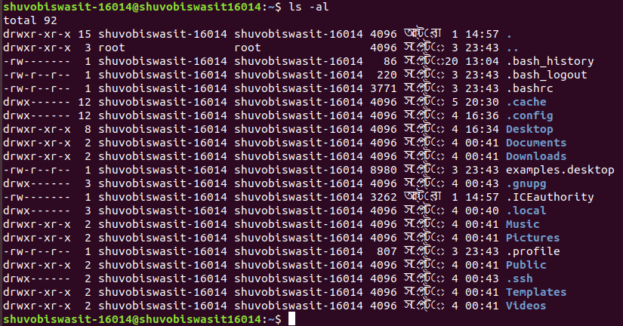

Next to each file and directory, we will see a special section that outlines the permissions it has. It looks like this:

**-rwxrw-r-**

Where the r stands for “read,” the w stands for “write,” and the x stands for “execute.” Directories will be started with a “d” instead of a “-“. We also notice that there are 10 spaces which hold value. We can ignore the first and then there are 3 sets of 3. The first set is for the owner, the second set is for the group, and the last set is for the world.

To change a file or directory’s permissions we used the basic command chmod.

chmod [class][operator][permission] file

chmod [ugoa][+ or –] [rwx] file

Where ‘**u**’ is for the owner.

‘**g**’ is used for the group.

‘**o**’ is used for all others.

‘**a**’ will change permissions for all of the above.

The plus(**+**) sign is used to add the permissions which follow.

The minus(-) sign is used to remove the permissions which follow.

Here ‘**r**’ allows read access.

‘**w**’ allows write access.

‘**x**’ allows execution.

**Discussion:**

From this lab,we learnt about how to implement file operation and permission in Linux operating system by using command line. Here we use many file operation such as rmdir for remove directory, mkdir for creat a directory and ls -R for show text recursively. We also use varies file permission such as read permission grants the ability to read a file, write permission grants the ability to modify a file and execute permission grants the ability to execute a file.